Week 5 & 6 Excercise
Kia Thefts
Tejashri Bhilare
MS in Data Science, Bellevue University
DSC640 – Data Presentation and Visualization
Professor - Catie Williams
January, 2025

Data Storytelling: Kia & Hyundai Car Thefts

1. Audience
The target audience for this analysis is the general public, specifically Kia and Hyundai car owners, who may be unaware of the increasing theft risk associated with these vehicles. The audience is not expected to have a deep technical understanding of data, so the information is presented in a visually engaging and easy-to-understand manner

2. Purpose
The primary goal of this data storytelling exercise is to raise awareness about the surge in Kia and Hyundai car thefts and to urge car owners to take precautions such as installing security devices or following safety recommendations. The call to action is clear: be informed and take preventive measures to reduce the risk of theft.

3. Medium
This data story will be presented in the form of an infographic or PowerPoint presentation. These mediums are chosen because they are:
- Visually engaging and effective for summarizing key insights.
- Easily shareable on social media or community forums.
- Simple to understand, even for non-experts.

4. Design Choices
To enhance readability and impact, the following Gestalt principles were applied:
- Color: A mix of red, orange, and yellow is used to indicate urgency and highlight the increase in thefts. Blue and green are used for general car theft trends to contrast with Kia/Hyundai-specific thefts.
- Text: Minimal, with key statistics highlighted in bold to draw attention.
- Alignment & Sizing: Data points are aligned logically to show trends, with larger font sizes for crucial numbers.
- Spacing: Adequate white space ensures clarity, preventing visual clutter.

5. Visualizations
To effectively convey the message, the following five visualizations were created using R:
- Pie Chart– Breakdown of Kia vs. Hyundai thefts to show which brand is more affected.
- Stacked Bar Chart – Theft trends over time by state/city, highlighting regional differences.
- Tree Map – The most affected cities or car models, showing theft concentration.
- Bar Chart – Comparison of Kia/Hyundai thefts versus other car brands.
- Map Visualization – Geographic distribution of theft incidents, showing hotspots.

Now , here comes the interesting part of all above things that we have covered.

📊1. Pie Chart– Kia vs. Hyundai: Who’s More at Risk?
"When it comes to car thefts, not all vehicles are targeted equally. This chart breaks down the thefts between Kia and Hyundai, revealing which brand is more vulnerable. If you own one of these cars, knowing where your vehicle stands can help you take the right precautions!"

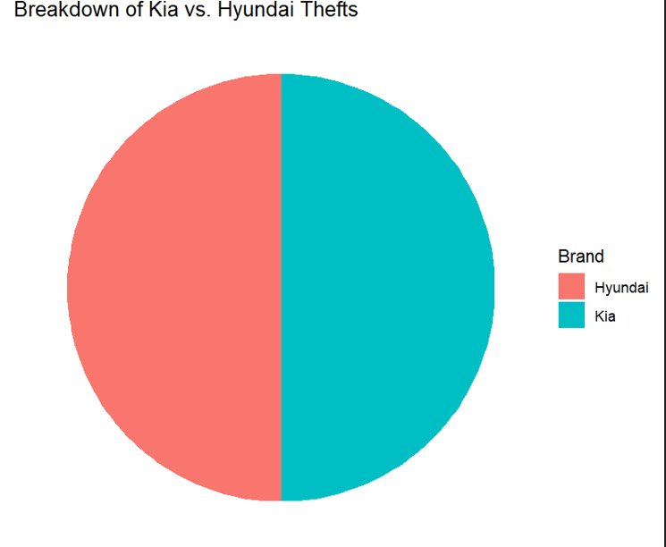

📈 2. Stacked Bar Chart – Where Are Thefts Rising the Fastest?

"Car theft isn’t just a national issue—it’s a local one. This chart tracks theft trends over time in different cities and states, showing where the problem is growing the fastest. If your city is on the rise, now is the time to act before it’s too late!"
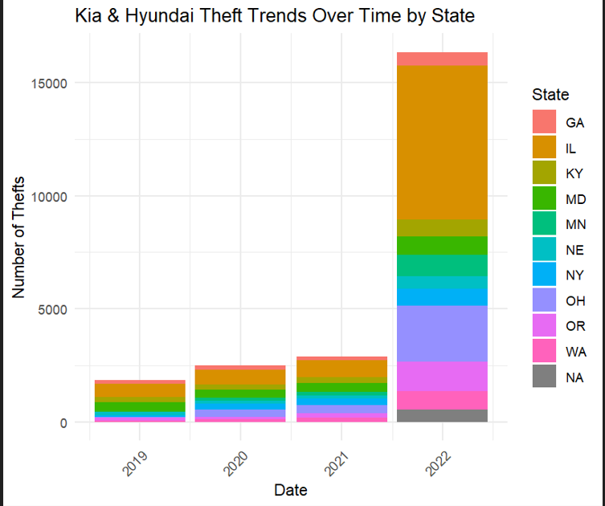

🌆 3. Tree Map – The Hardest-Hit Cities & Models
"Not all Kia and Hyundai models are stolen at the same rate, and some cities are facing a bigger crisis than others. This visualization highlights the worst-hit areas and the specific models that thieves are targeting the most. Does your car make the list? If so, it’s time to boost your security!"

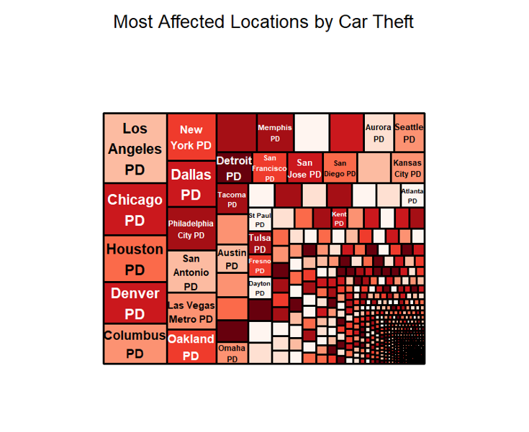
🚘 4. Bar Chart – Kia & Hyundai vs. Other Brands: Are They Really Easier to Steal?
"Are Kia and Hyundai thefts really that bad, or is this just media hype? This chart puts the numbers into perspective by comparing thefts of these brands to other popular cars. The results might shock you—some cars are just much easier targets!"

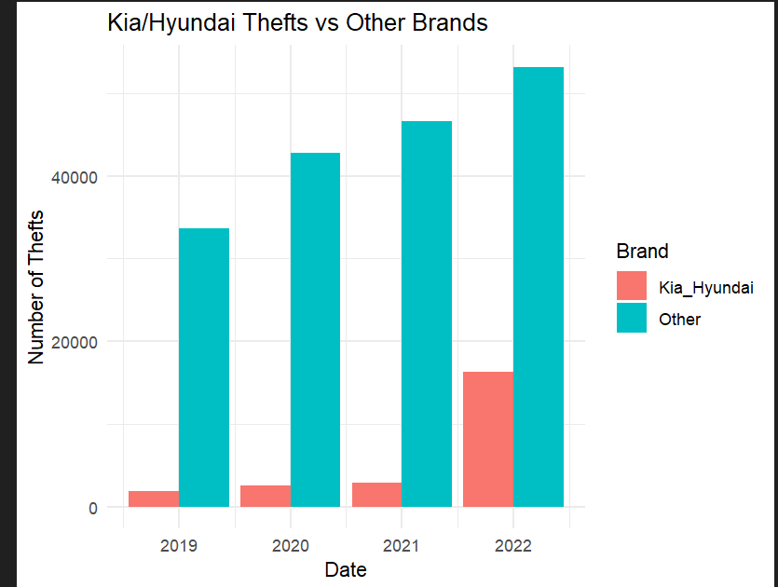

🗺️ 5. Map Visualization – Where Are Thefts Happening the Most?
"Car theft hotspots exist, and this map pinpoints where they are. Whether you're parking in these areas or just passing through, knowing the high-risk zones can help you stay alert and keep your vehicle safe!"

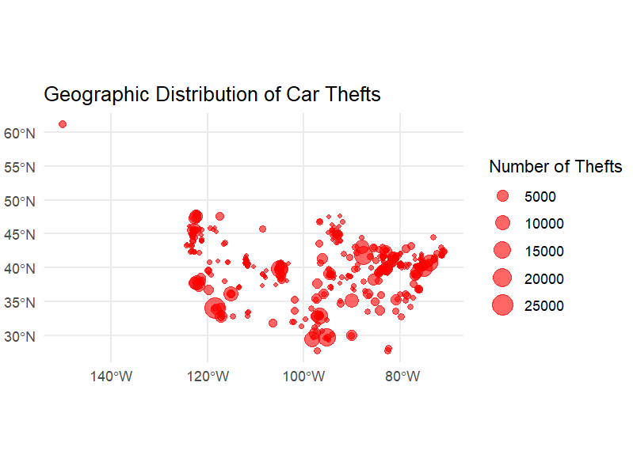

6. Ethical Considerations
- Data Modifications: No significant alterations were made beyond aggregation for visualization purposes.
- Regulatory Compliance: The data sources were verified, and no personally identifiable information (PII) was included.
- Potential Risks: Overemphasizing the rise in thefts could cause unnecessary panic. The visualizations ensure balanced reporting by providing context rather than sensationalizing trends.
- Filtering & Assumptions: Data was filtered to focus on Kia and Hyundai thefts. This was clearly labeled to avoid misleading conclusions.
- Data Credibility: The datasets were sourced from reputable sources such as police reports and government records. Any missing values were handled transparently.

7. Conclusion & Call to Action
The data clearly shows a rapid increase in Kia and Hyundai car thefts, making it essential for owners to take preventive measures such as:
- Using steering wheel locks or engine immobilizers.
- Parking in well-lit or secured areas.
- Checking for software updates or manufacturer recalls that improve security.
By staying informed and taking proactive steps, car owners can reduce the likelihood of theft and protect their vehicles.

